Name of The Department : Computer Engineering
Event name: | SSIP 2.0 Sensitization Program organized by K.D.Polytechnic Patan
Date & Time: | 19/1/2023 12Noon TO 12:30PM
Description: | 89 Students of 3rd semester Computer Department attended session on SSIP 2.0 Sensitization Program. Mr.Y.R.Patel lecturer Computer Department delivered lecture on SSIP 2.0. He discuss SSIP 2.0 policy and its benefits for students
Registration Link | HTTPS://DOCS.GOOGLE.COM/FORMS/D/ E/1FAIPQLSFAT6SRSIKBRWHOOND_XC9RPN6C9SRCOTVR5GY6- W_FPR6SG/VIEWFORM?USP=SF_LINK
Photograph1: | 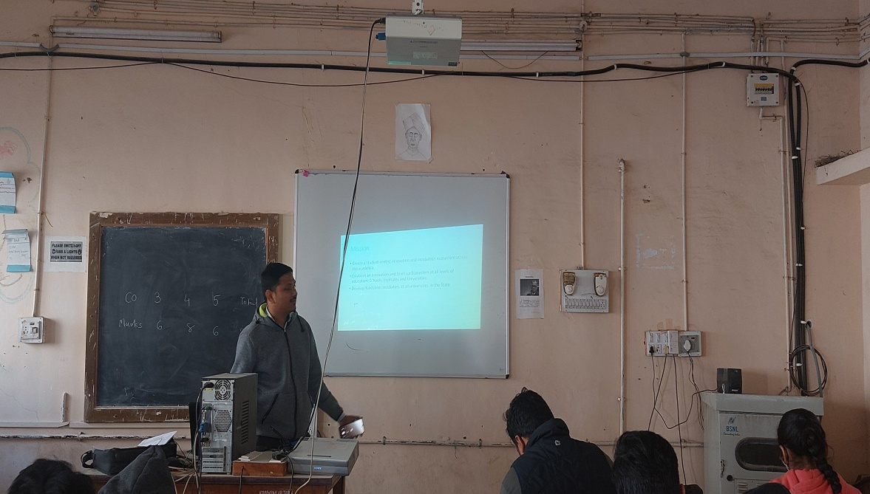
Photograph2:

Photograph3: | 